Hands-On Lab: Cloning and Forking GitHub Projects
After completing this lab you will be able to use git commands to manage upstream repositories:
- fork existing repository using the UI
- clone forked repository in the lab environment
- create a new branch
- make changes locally
- add and commit to local branch
- push changes to your forked repository
- create a pull request to the upstream repository
If you are unable to open the lab, please click here to view the HTML version.
- If you do a git status at this point, you will see a change is shown. This change is not staged at this point, but Git is aware of it.
git status
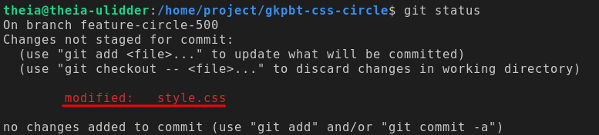
- Optionally, you can use the git diff command to see the detailed changes:
1git diff ./style.css
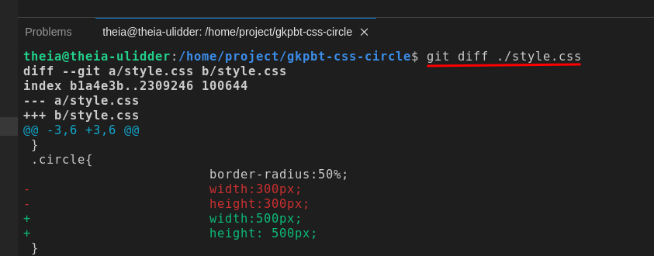
Notice the text in red was deleted and the text in green was added. Essentially, we changed the height and width from 300px to 500px each.
Note: To exit the git diff command, simply press the "Q" key.

Add and commit your changes
A commit is Git's way of recording your file changes, similar to how you might save an edited document. To commit the change that you made in the previous exercise, you first need to add it to a staging area. Git will then take the staged snapshot of changes and commit them to the project. Remember, Git will never change files unless you explicitly ask it to.
To commit your new file, complete the following steps:
- To move the changes from your working project directory to the staging area, type the following command in the Terminal window:
1git add .Copied!
The git add command has several options. The single . adds all untracked files in the current directory and subdirectories to the staging area. Alternatively, you can add the single file you created by using the git add style.css command. Finally, you can use git add -A to recursively add all files from the top level git folder.
- If you check the status at this point, you will see the file has changed from Untracked to Changes to be committed:
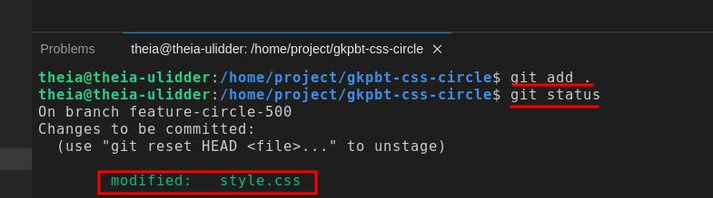
- To commit the new file to the local repository, you need to first tell git who you are. Type in the following commands to set your email and username. The email should be the same as your GitHub email.
Set your email:
git config --global user.email "email@example.com"
Set your name:
git config --global user.name "Your Name"
4.Type the following command in the Terminal window to commit the file.
Note: It's always a good practice to add a description for the commit so you can remember what the change was if you have to refer to it later.

- -m flag: It is used in Git commit commands to specify the commit message directly in the command line, allowing you to provide a brief description of the changes you are committing.
1git commit -m "Changing the height and the width of the circle"Copied!
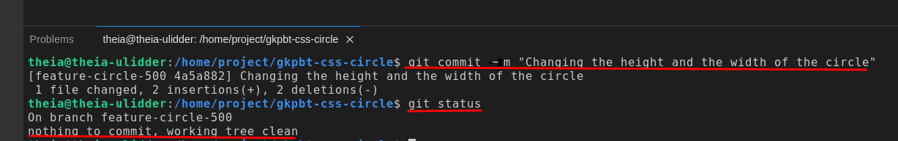
As you can see, git status now says there is nothing to commit and the working tree is clean. The new file is now ready to be pushed from your local system to origin on GitHub.

Merge your branch back into main branch
If you are happy with your changes in the feature-circle-500 branch, you can now merge it back into your local main branch by following these steps:
- Confirm that you are currently in the feature-circle-500 branch.
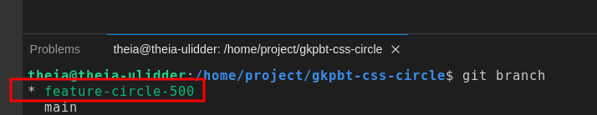
- Check out the main branch
1git checkout mainCopied!
If you run git branch again, you should see the * against the main branch.
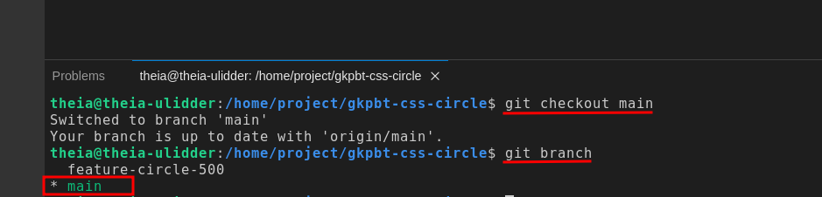
- Merge the feature-circle-500 branch intomain.
1git merge feature-circle-500Copied!
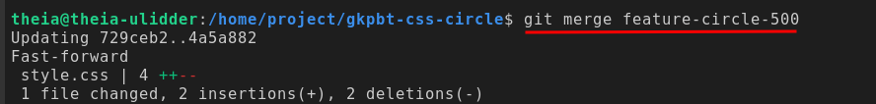
- Confirm the change was merged by using the git log command. We are using --oneline flag to display logs more concisely.
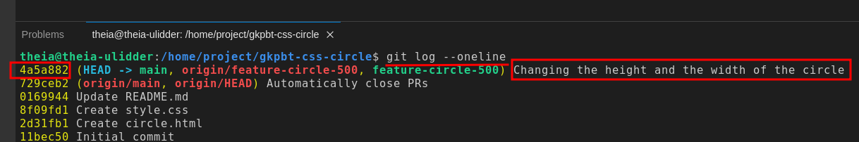
Note: To exit the git log command, simply press the "Q" key. This action will close the log view and bring you back to the command prompt.

Delete the feature-circle-500 branch
Since you are done making the change, let's delete the feature-circle-500 branch by following these steps:
- Ensure you are on the main branch. If not, check it out first
1 git checkout mainCopied!
- Delete the feature-circle-500 branch, the common flag used is -d (lowercase), which stands for "delete"
1git branch -d feature-circle-500
- You can confirm the branch was deleted by listing all branches
1git branch
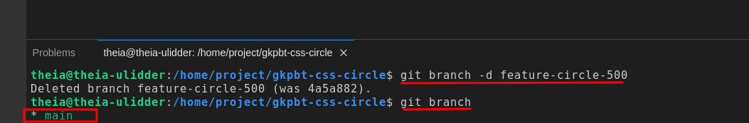

Push your changes to origin
This push will synchronize all the changes you made on your local system with your fork repository on GitHub.
To push your update to GitHub, complete the following steps:
- In the Terminal window, run the following command:
1git push origin mainCopied!
Once you submit that command, Cloud IDE will display a dialog in the lower right corner, requesting permission to sign in using GitHub. Click "Allow"
Note : If you don't see the dialog box below, you will be asked to enter your GitHub username and password in the terminal. Your PAT (Personal Access Token) will be hidden when you type or paste it in the terminal for security reasons. So, make sure you enter or paste it correctly before hitting 'Enter'.
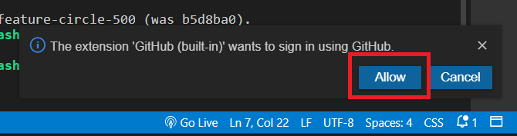
Note: If you come across a message like the one in the screenshot below, which says "Sign in failed: Error: Invalid scheme theia", please ignore this error.
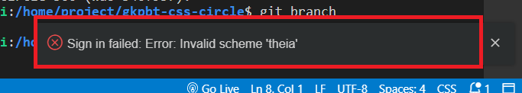
Subsequently, another dialog will appear at the top of the screen, prompting you to enter your username and password. The username is your email you used to sign into GitHub and the password is the Personal access token you created in Exercise 1 - This is not you GitHub password.
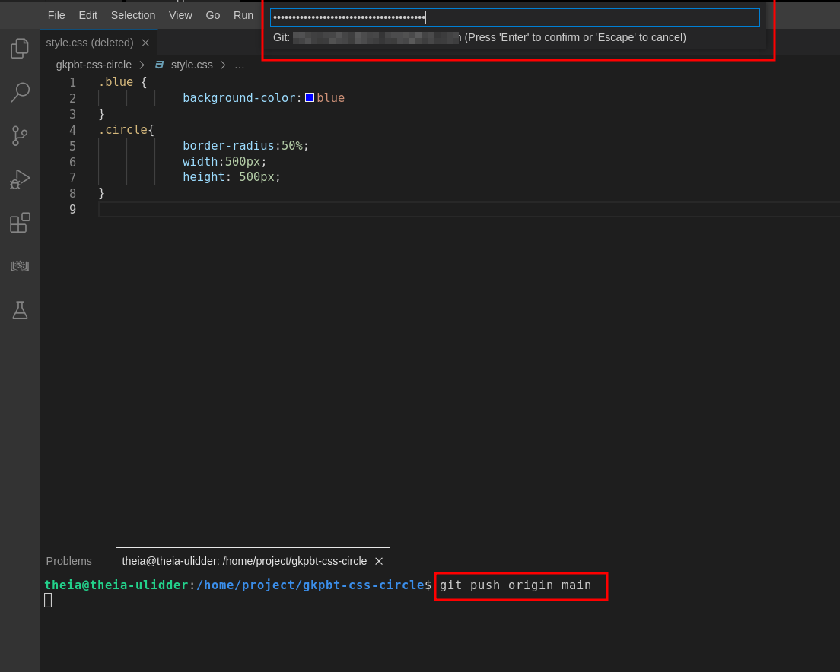
If your username and password were accepted, you should see the changes pushed to GitHub in the terminal.
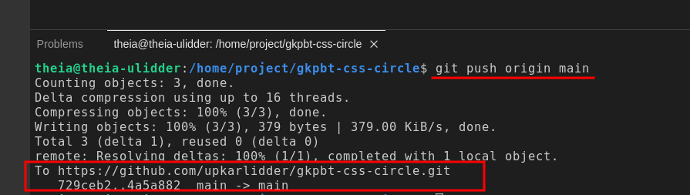
- Go to the fork repository in your GitHub account and verify that the local changes have now been added to the main branch.
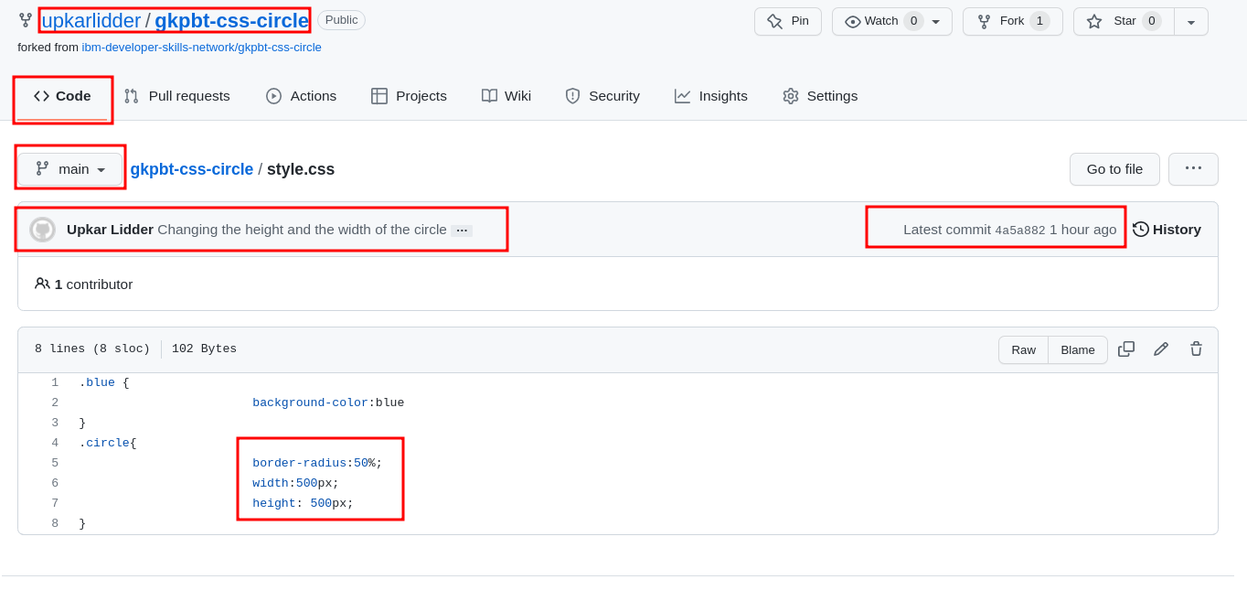

Create a pull request
The final step is to request the original project pull in the changes you've made to your fork. To merge your changes to the original repository, you need to create a pull request.
To create a pull request, complete the following steps:
- Ensure you are on the Code tab. Click Contribute and then Open pull request.
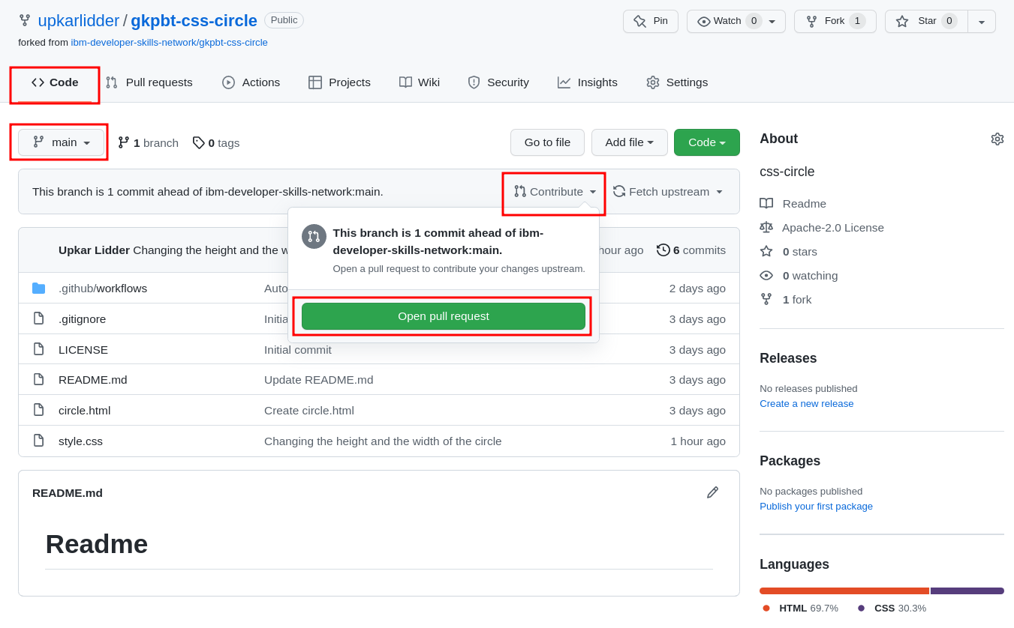
- In the "Comparing changes" panel, GitHub shows you that it is comparing the main branch of your fork to that of the original repository, and that your changes can be merged. Click the Create pull request button.
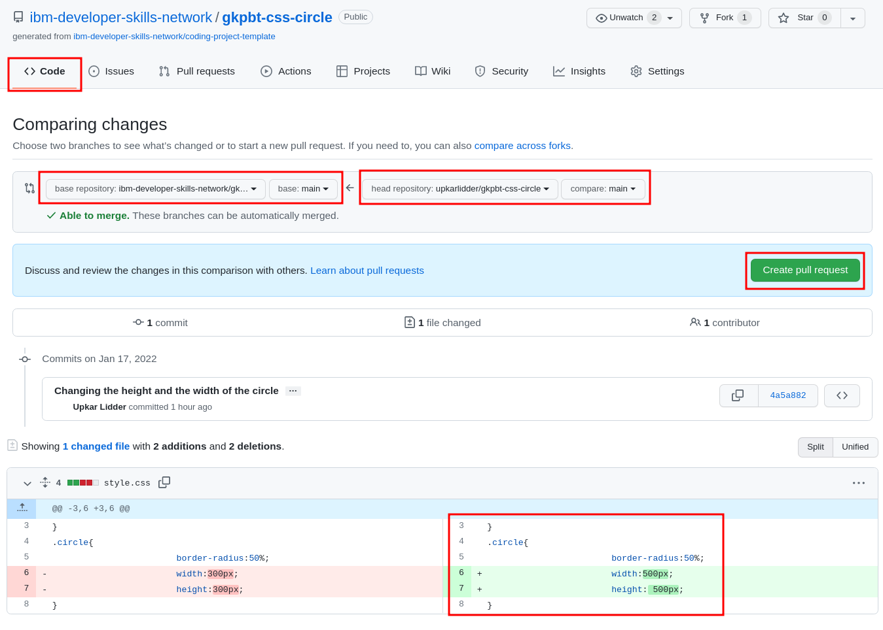
- You are taken to the Open pull request screen. Notice that your commit message appears as the title of the pull request. Click the Create pull request button.
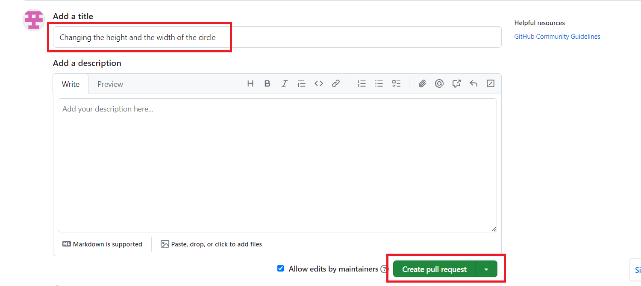
Note: For the purposes of this lab, your pull request will be processed and closed automatically.
You should see the following message in your pull request after a few minutes:
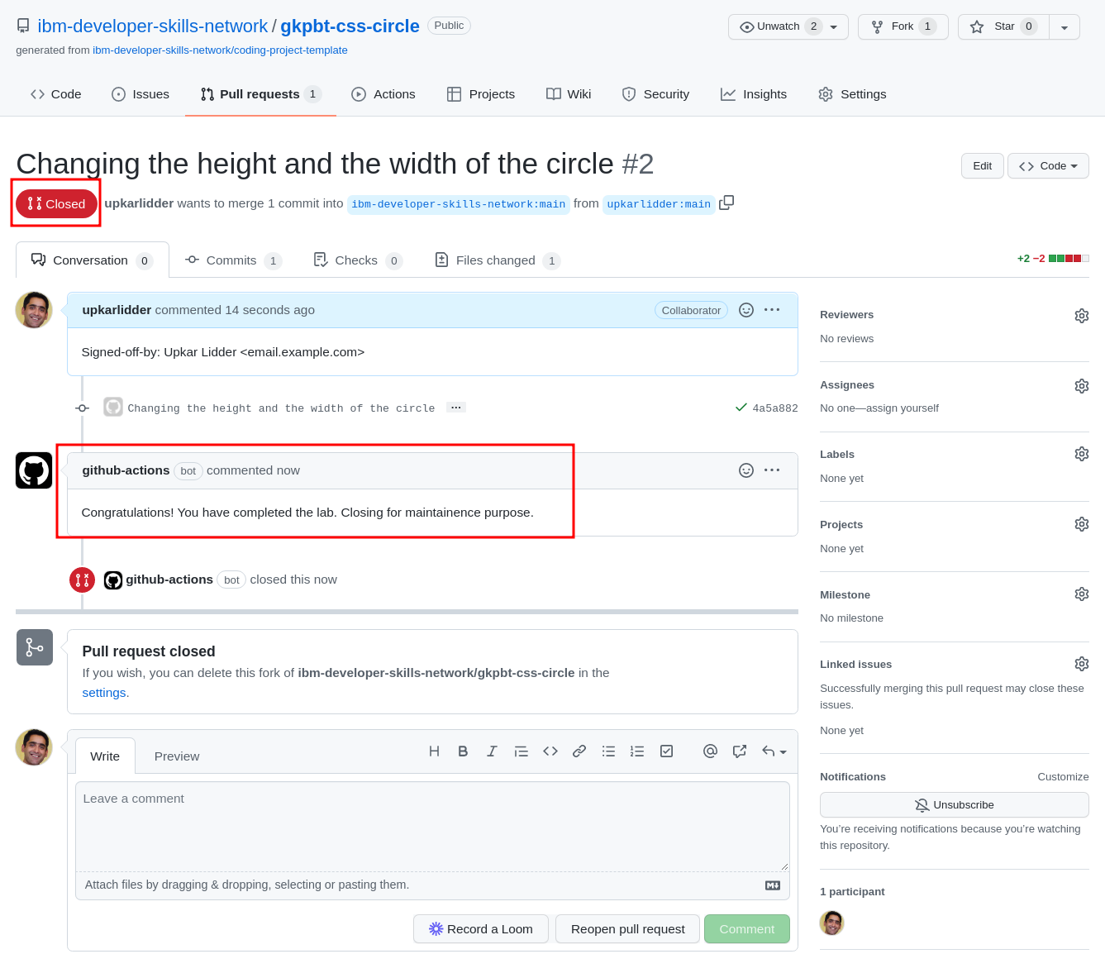

Practice on your own
- Create a new branch called feature-add-color.
Click here for the solution
1git branch feature-add-color
- Make feature-add-color the active branch.
Click here for the solution
1git checkout feature-add-color
- Add another css rule as follows:
123.red { background-color:red }
- Stage this change.
Click here for the solution
- Commit the changes in your feature-add-color.
Click here for the solution
- Merge the changes in feature-add-color into main.
Click here for the solution
1git checkout main && git merge feature-add-colorCopied!Executed!
- Delete the feature-add-color branch.
Click here for the solution
1git branch -d feature-add-color
- Create a new pull request for this feature in the upstream repository using the GitHub UI.

Summary
In this lab, you have learned how to fork an upstream repository into your own account and then clone it locally in the lab environment. You then learned how to synchronize changes in your local repository with remote GitHub repositories using pull requests.

